Neural Networks
Ref. No.: NEUNET-D-25-05585R1

DSN: Energy-Efficient EMG Signal Classification Method Enabling Real-Time Monitoring for Edge Healthcare Engineering and Applications

Response Letter to Reviewers’ Comments

Comments from the Editor:

After revision, there are still several major concerns raised in the last round still remains. Some major concerns are summarized as follows.

1. Response of missing details of essential methodology seems to be mismatched as reported by the reviewer.
2. Comparisons and statements are challenged to be less supportive to the strength.
3. Clarifications and discussions are required.

Detailed comments from each individual reviewer are as follows.

Response: We sincerely appreciate your careful review and valuable feedback on our revised manuscript. We fully acknowledge the three major concerns you summarized as these align with the detailed comments provided by the reviewers. We have implemented rigorous measures to address each concern comprehensively with all revisions directed toward enhancing the manuscript’s quality logical consistency and academic rigor. A detailed response to the major concerns raised is provided below.
We sincerely apologize for the previous mismatch in addressing essential methodology details. Reviewer #2 identified conflicting statements regarding the model’s training strategy and ambiguity in the definition of one-step training prompting thorough revisions to relevant content in Sections 3.2 and 4.1. We have clarified that hidden-layer weights are randomly initialized and not subjected to iterative training or repeated backpropagation consistent with our core design objective of eliminating complex optimization. The lightweight one-step training has been explicitly defined as a single forward-backward pass over the entire training dataset at the initialization stage representing a one-shot parameter update rather than formal iterative training. All inconsistent expressions have been unified to ensure logical consistency and clarity. We have also corrected citation inconsistencies related to SVM in Section 4.2 and Table 2 as well as the mismatch between textual descriptions and Figure 3 in Section 4.3 thereby enhancing the accuracy of methodology presentations.
To address insufficient support for the strength of comparisons and statements we have implemented targeted revisions. We revised wording related to classification accuracy to clearly define the scope of comparison ensuring all statements are fully supported by experimental data particularly addressing discrepancies between descriptions of DSN performance and results presented in Table 2. We supplemented the robustness analysis with a comprehensive comparison between the proposed DSN and five representative baseline models including 1D-CNN LSTM TCN SVM and ViT under conditions of increasing noise probability. These new results presented in the revised manuscript demonstrate the superior robustness of the DSN and strengthen support for the model’s advantages. We have independently presented additional verification results from the self-collected dataset through the inclusion of a new subsection and accompanying table. This new content details the data acquisition protocol experimental setup and performance metrics derived from 10-fold cross-validation establishing a clear connection between the self-collected dataset and main experimental evidence to enhance the persuasiveness of the model’s generalization capability. We have also clarified the definition of core computations in the context of energy consumption measurement specifying that this scope includes all key operations directly related to model inference while excluding unrelated processes to ensure the interpretability and fairness of energy comparisons.
We have comprehensively addressed the need for further clarifications and discussions. In response to Reviewer #3’s comment regarding a mismatch between the previous response letter and the original query on energy consumption measurement we have corrected this correspondence in the current letter to accurately address the methodology for energy consumption measurement. We have verified that the revised content in Section 4.2 which details the measurement tool definition of core computations and data processing fully answers the reviewer’s original query. We are committed to strictly verifying the correspondence between questions and responses in future communications to prevent such errors. We have also supplemented detailed discussions in the revised manuscript encompassing interpretations of experimental results advantages of the proposed DSN framework and practical implications for edge healthcare applications. Additionally we have polished the manuscript’s language and format to ensure clarity and adherence to academic standards.
In summary we have thoroughly addressed all major concerns raised by you and the reviewers. The revised manuscript has been significantly improved in terms of methodology clarity experimental support and logical consistency. We sincerely hope the revised version now meets the journal’s requirements and we would greatly appreciate your further review and guidance.

---------------------------------------------------------------------------------------------------------------------

Reviewer #1:

The authors have responded to my comments point by point, and the newly added discussion and experimental results are highly convincing. I have no further comments. Compared with the original submission, the revised manuscript shows significant improvements in both quality and formatting; therefore, I am inclined to accept the paper.

Response: We sincerely appreciate the reviewer’s careful evaluation and positive recognition of our work. We are grateful for the valuable comments and suggestions that have greatly helped us improve the quality and presentation of the manuscript. We are pleased that the revised version has met the reviewer’s expectations.

Reviewer #2:

Thank you for the detailed responses, which have clarified some of my previous concerns. The overall idea of combining SNN-based processing with HDC for this task is interesting. However, after carefully reading the revised manuscript, I believe that several important issues remain insufficiently resolved:

Response: We are deeply grateful for your positive feedback and thoughtful review. We have revised the manuscript thoroughly in light of your professional suggestions. All revisions are designed to fully address your concerns and enhance the quality of this work.

1. I appreciate the authors' clarification regarding the weight-setting strategy. However, the revised manuscript still contains conflicting statements. Section 3.2 states that the model "only performs a lightweight one-step training using surrogate gradient" and mentions a "lightweight one-step back-propagation." In contrast, Section 4.1 states that the hidden-layer weights "remain untrained to avoid complex optimization, consistent with our core design of eliminating backpropagation." These statements appear difficult to reconcile. In addition, the meaning of "one-step training" remains unclear: it is not clear whether this refers to one time step, one update per batch, one update per epoch, or a single update over the entire training procedure.

Response: We sincerely appreciate the reviewer for identifying the conflicting descriptions and the ambiguous definition of “one-step training” in our manuscript. We have carefully revised the relevant content in Sections 3.2 and 4.1 to ensure logical consistency and clarity throughout the paper.
To resolve the contradiction, we clarify that the hidden-layer weights are randomly initialized and not subjected to iterative training or repeated backpropagation, which conforms to our core design of eliminating complex optimization. The “lightweight one-step training” mentioned in Section 3.2 only denotes a single forward-backward pass over the entire training dataset at the initialization stage, which is a one-shot parameter update rather than formal iterative training. Therefore, the statement that weights remain untrained in the conventional sense is still valid.
We further define “one-step” explicitly as one full forward propagation plus one full backward propagation over the entire training set, with only one weight update in the whole process. It does not refer to one time step, one batch, one epoch, or iterative optimization. All inconsistent expressions have been unified and revised to avoid misunderstanding.
---------------------------------------------------------------------------------------------------------------------
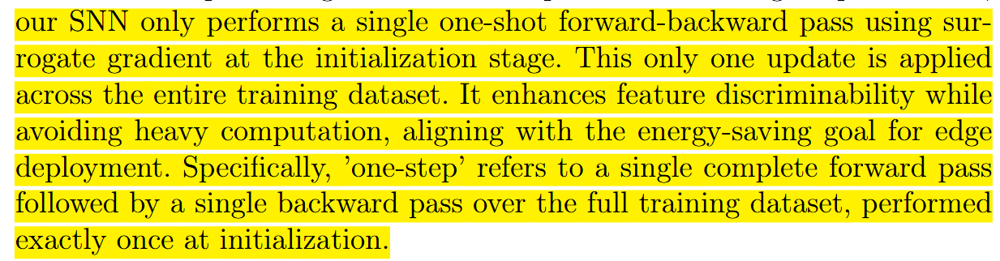
(See Section 3.2)
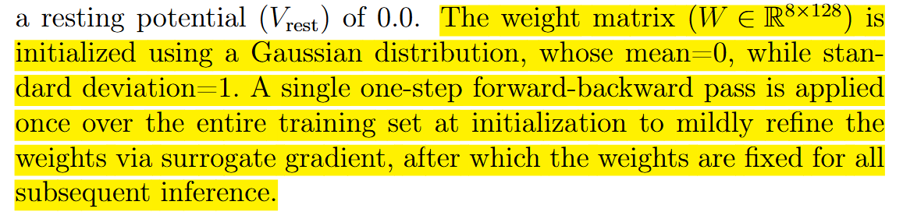
(See Section 4.1)

---------------------------------------------------------------------------------------------------------------------

2. I appreciate the clarification that all core experiments are based on the Cerqueira public dataset, while the self-collected dataset is used only for "additional performance verification." However, the revised manuscript still does not independently present these additional verification results. As a result, the inclusion of the self-collected dataset still feels abrupt and insufficiently connected to the main experimental evidence.

Response: We sincerely appreciate the reviewer's professional insight. We agree that the initial inclusion of the self-collected dataset lacked sufficient context and independent analysis. In the revised manuscript, we have addressed this concern by implementing the following updates:
- Independent Presentation: We have added a new subsection, "Section 4.9: Generalization and Practical Verification on Self-collected Dataset", to independently detail the data acquisition protocol, experimental setup, and performance analysis.
- Explicit Acquisition Details: We have clarified that the self-collected data was obtained using a multi-channel SEMG sensing system from 5 subjects to simulate real-world noise and sensor displacement. This information provides the necessary background for the supplementary experiments.
- Comprehensive Data Evidence: A new summary table (Table 4) has been introduced, presenting a full suite of metrics (Accuracy, Energy, Latency, etc.) derived from a 10-fold cross-validation.
We believe these revisions successfully bridge the logical gap and demonstrate the generalization capability of our framework.
---------------------------------------------------------------------------------------------------------------------
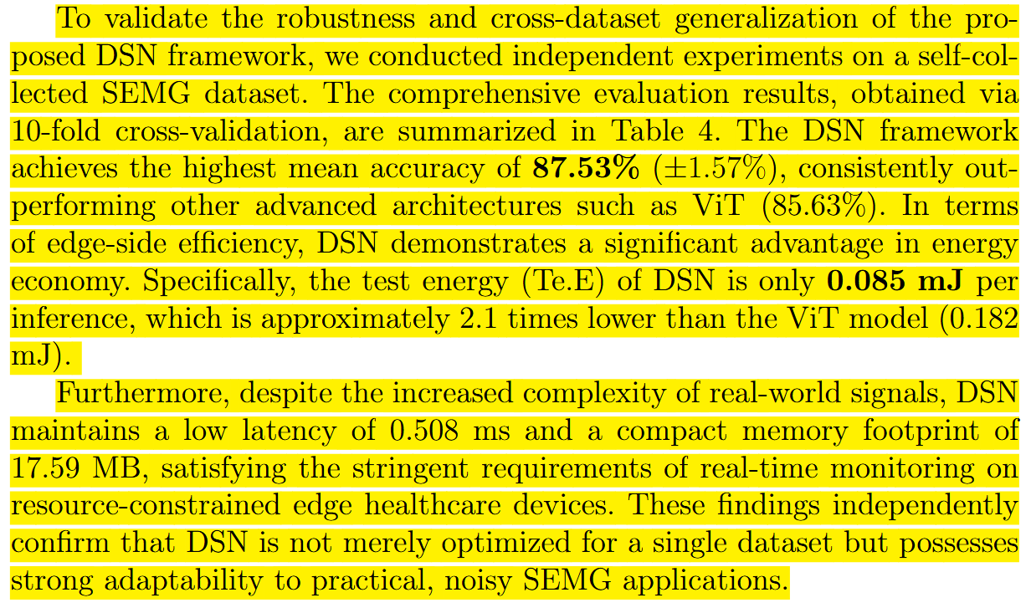
(See Section 4.9)
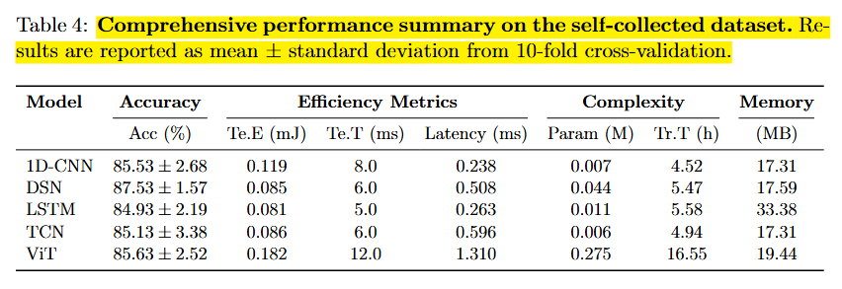
(See Table 4)
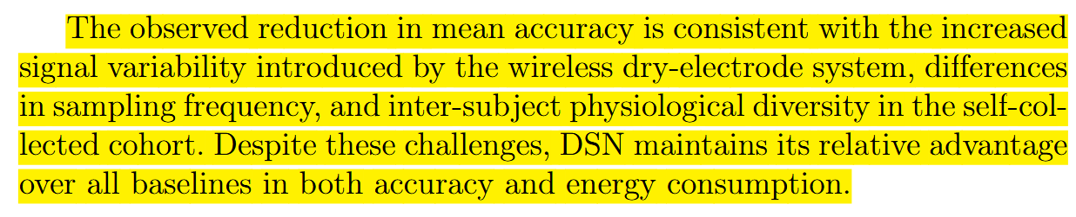
(See Section 4.9)
---------------------------------------------------------------------------------------------------------------------

3. The added explanation of the energy measurement procedure is appreciated. However, the manuscript states that the reported energy "captures only core computations," but the definition of "core computations" remains unclear. Without clarifying what is included in or excluded from this measurement, the energy comparison is difficult to interpret.

Response: We thank the reviewer for this valuable comment. We have added a clear definition of core computations in the manuscript to ensure the energy consumption results can be fully understood and fairly compared. Core computations include all key operations directly related to model inference while all unrelated processes are excluded. No additional experiments are needed as the measurement scope is now clearly specified.
---------------------------------------------------------------------------------------------------------------------
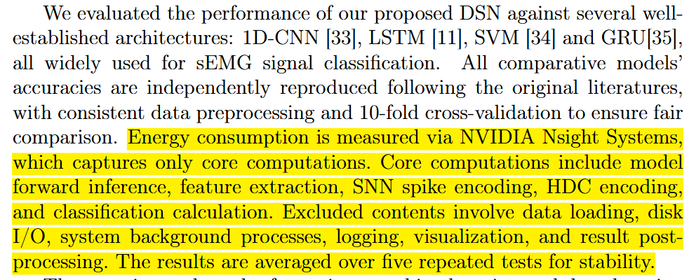

(See Section 4.2)
---------------------------------------------------------------------------------------------------------------------

4. The manuscript states that "DSN consistently achieved the highest classification accuracy among all evaluated architectures." However, Table 2 shows that the reported accuracy of DSN (94.40%) is lower than that of Transformer (96.16%) and TimesNet (98.04%). This statement therefore does not seem to be supported by Table 2. The authors should revise the wording or clearly define the scope of comparison.

Response: We thank you for this valuable suggestion. We agree that more detailed figure captions can help readers better understand the experimental results and their implications. In response, we have revised figure captions to provide comprehensive explanations of what each figure demonstrates and why it matters for the algorithm evaluation.
---------------------------------------------------------------------------------------------------------------------

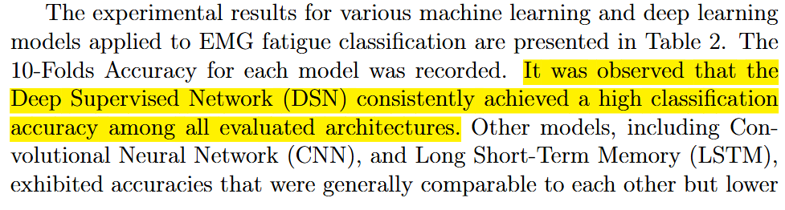
(See Section 4.2)

---------------------------------------------------------------------------------------------------------------------

- Although the response letter states that the citation inconsistency has been corrected, the current text in Section 4.2 still refers to SVM as [34], while the table still lists SVM as [36]. This inconsistency remains and should be corrected.
Response: We sincerely apologize for the citation inconsistency in Section 4.2 and Table 2. We have carefully checked and uniformly revised all citation numbers of SVM in the manuscript to ensure full consistency. The citation label for SVM in Section 4.2 is now aligned with that in Table 2, and all related reference numbers have been verified and corrected.
---------------------------------------------------------------------------------------------------------------------
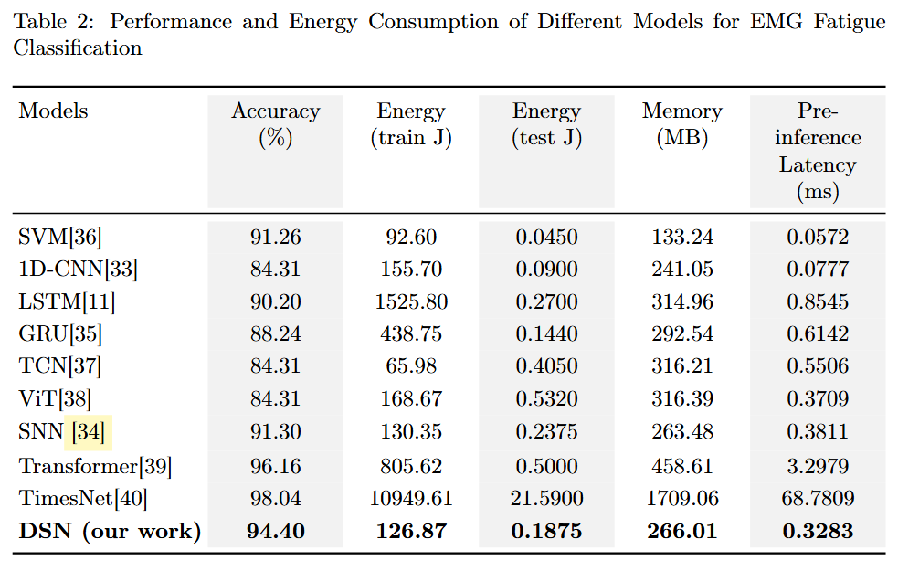
(See Table 2)

---------------------------------------------------------------------------------------------------------------------
- Although the authors explained why additional robustness experiments were not included, the most important baseline comparisons are still missing. As a result, the current robustness analysis still appears insufficiently supported.
Response: We sincerely appreciate the reviewer’s comment regarding the lack of baseline comparisons in the robustness analysis. We have addressed this issue by adding a comprehensive robustness evaluation, in which we compare the proposed DSN with five representative models (1D-CNN, LSTM, TCN, SVM, and ViT) under increasing noise probability. As shown in Figure.6, the DSN maintains high accuracy across all noise levels, demonstrating remarkable stability and robustness. In contrast, other models, particularly ViT and SVM, show significant performance degradation with increasing noise. These results clearly demonstrate that the DSN is resistant to noise perturbations and thus more reliable for real-world heart sound applications. We have carefully checked and ensured the consistency between the experimental results and the manuscript text. The revised robustness analysis now fully supports the conclusion that the DSN exhibits superior robustness compared to state-of-the-art baselines.
---------------------------------------------------------------------------------------------------------------------
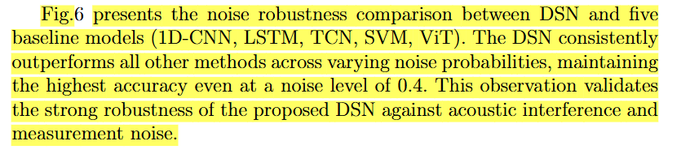
(See Section 4.5)
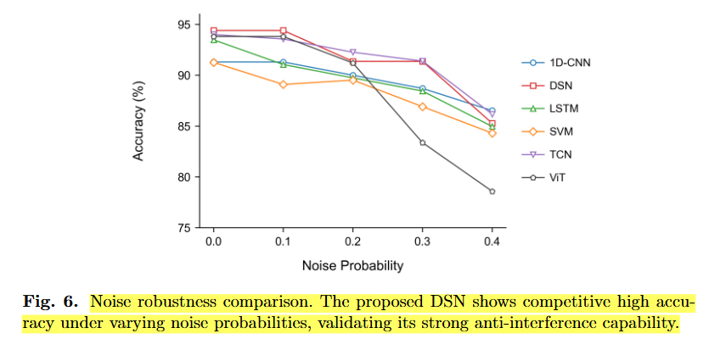
(See Fig. 6)

---------------------------------------------------------------------------------------------------------------------

- The beginning of Section 4.3 states: "As illustrated in Figure 3, the confusion matrices for the DSN, 1D-CNN, and LSTM models on the test dataset…". However, Figure 3 actually presents four models, including SVM, and the caption also states "Confusion matrix for 4 models." The text therefore does not match the figure and should be corrected for consistency.
Response: We sincerely appreciate and we are grateful for your careful check. We have revised the description in Section 4.3 to ensure full consistency with Figure 3. The text now correctly lists all four models (DSN, 1D-CNN, LSTM, and SVM) as presented in the figure and its caption. All mismatches have been corrected thoroughly.
---------------------------------------------------------------------------------------------------------------------
(See Section 4.3)

---------------------------------------------------------------------------------------------------------------------

Reviewer #3:

I have carefully reviewed the revised manuscript and the response letter. I appreciate the efforts made to address most of my concerns. In particular, the addition of memory footprint and inference latency in Table 2, as well as the inclusion of a recent SNN-based sEMG study for comparison, have significantly strengthened the paper. I am satisfied with the responses to my Question 2 and Question 3.

Response: We greatly appreciate your careful review and valuable comments on our revised manuscript.We are pleased to learn that you are satisfied with our revisions addressing Questions 2 and 3, including the addition of memory footprint and inference latency in Table 2, as well as the inclusion of a recent SNN-based sEMG study for comparison.We have further polished the language and format of the manuscript to ensure its clarity and academic standard.We sincerely hope that the revised version now meets your approval and the requirements of the journal.

However, I must point out an inconsistency regarding my Question 1. In my initial review, I asked about "the methodology for measuring energy consumption" - specifically, how the reported energy values were obtained. In the response letter, the authors provided a detailed explanation about the exclusion of the GRU model from the confusion matrix, which was not the question I raised. This suggests a possible misalignment in the response compilation. Nonetheless, I did notice that in the revised manuscript, specifically in Section 4.2: "Energy consumption is measured via NVIDIA Nsight Systems, which captures only core computations, and the results are averaged over five repeated tests for stability."
This addition satisfactorily answers my original query. However, the mismatch between the response letter and the actual question should be corrected to avoid confusion in future communications. I recommend that the authors double-check the response letter to ensure that each comment is matched with the correct reply.

Response: We sincerely apologize for the serious mistake in our previous response. We incorrectly addressed the issue of excluding the GRU model from the confusion matrix instead of answering your question about the energy consumption measurement methodology, which was caused by an error in collating our responses.
We have now carefully verified the description of energy consumption measurement in the revised manuscript. The measurement approach has been clearly supplemented in Section 4.2, including the tool used, the definition of core computations, and the processing of experimental data.
We greatly appreciate your careful reminder and will strictly check the correspondence between questions and answers to avoid such errors in future communications.
---------------------------------------------------------------------------------------------------------------------
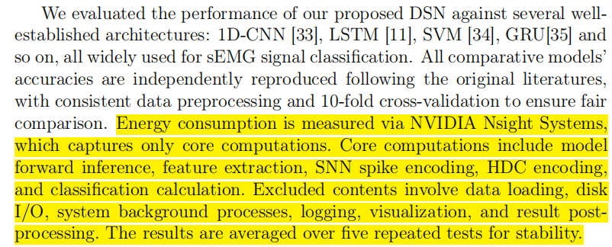
(See Section 4.2)

---------------------------------------------------------------------------------------------------------------------

